Norfolk County Council (Costessey)
Emergency Notice

Temporary Traffic Regulation Order 2024
Section 14(2) of the Road Traffic Regulation Act 1984

Costessey (STRO11675) Notice

In accordance with the provisions of Section 14(2) of the Road Traffic Regulation Act 1984, the Norfolk County Council HEREBY GIVE NOTICE that owing to gas leak and pipe works the use by vehicles (of any class) of the C162 Longwater Lane from its junction with U78395 Longdell Hills for 400m northwards (the “Road”) in the Town of Costessey will be temporarily prohibited.

Alternative route is via: C162 Longwater Lane, West End, Townhouse Road, Norwich Road, Dereham Road.

The closure is necessary because of the likelihood of danger to the public or serious damage to the road or both.

The closure is anticipated to take place from 3rd to 8th October 2024 but the Road may continue to be closed until the 23rd October 2024 where the closure is still required beyond the anticipated dates.

This Notice shall automatically revoke on the completion of the works / when the closure is no longer necessary or otherwise on the 23rd October 2024 without further notice.

If necessary, this Notice may be extended for an additional 21 days by further Notice and/or for a maximum of 18 months from the date this Notice is effective by further Order.

A person who contravenes, or who uses or permits the use of a vehicle in contravention of the restriction/ closure imposed by the Order shall be guilty of an offence.

Penalty: £1000 maximum fine on conviction and/or endorsement for contravention.

Full details on the closure are available at https://one.network. Any enquiries that cannot be answered on the one.network website should be directed to the South Area Streetworks (Community and Environmental Services Department) contactable by telephone at 0344 800 8020 or email at streetworks@norfolk.gov.uk

Dated this 3rd day of October 2024.

Katrina Hulatt
Director of Legal Services (nplaw)
County Hall
Martineau Lane
Norwich
NR1 2DH

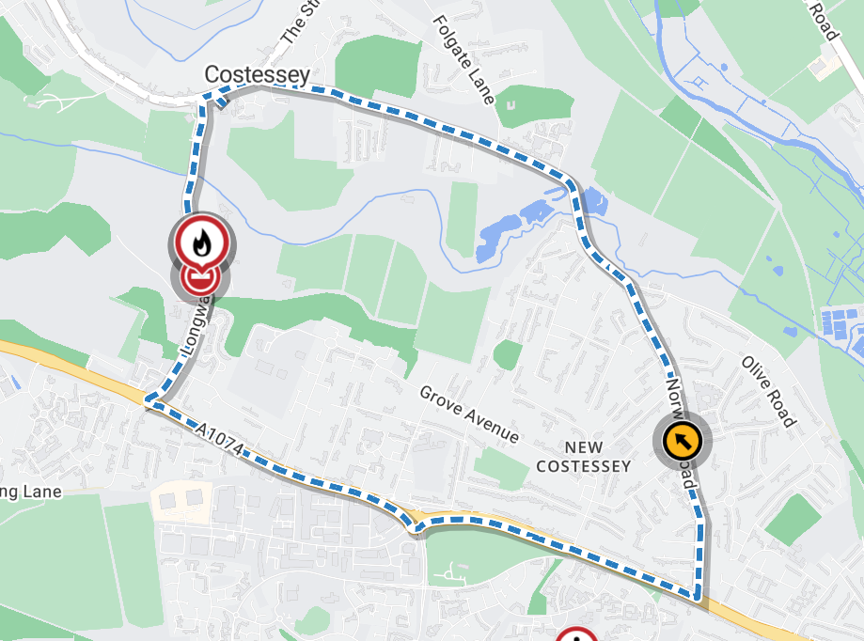
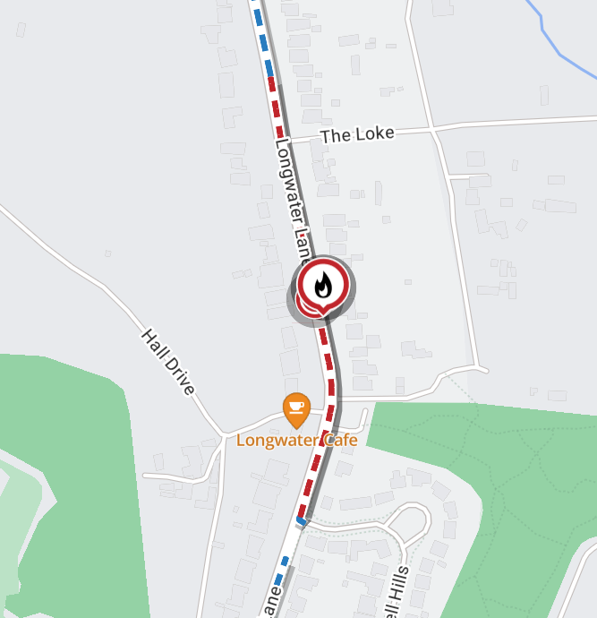
Map data © MapTiler © OpenStreetMap contributors

